Heinrich Hertz Technical Paper 2020

By James Duffy (17206286) and Eoin Flynn (15179818)

University of Limerick
E-mail: James Duffy 17206286@studentmail.ul.ie
Eoin Flynn15179818@studentmail.ul.ie

ABSTRACT

Our modern world stands on the shoulders of ancestors. Their findings form the foundations that inspire our today. Herinrich Hertz is one such historical person. He was the first person to conclusively prove the existence of electromagnetic waves via precise experimentation procedures. He also created scientific instruments to generate and detect these waves across space.

This paper provides insight in Hertz, the man who truly changed the world with his findings. Specifically, it focuses on his advancements and inventions he created when investigating Maxwell’s theory of electromagnetic waves.
I. Introduction

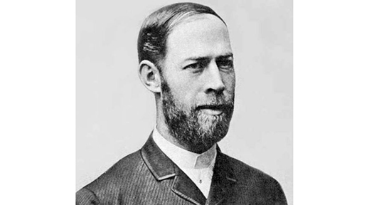

Figure 1.1 – Heinrich Hertz Source-Nationalmaglab.org
Heinrich Rudolf Hertz was born on February 22, 1857 in Hamburg and died January 1, 1894. He showed that the Scottish physicist James Clerk Maxwell’s studies and theory on electromagnetism was indeed correct, proving that light and heat are forms of electromagnetic radiation.
The unit of frequency, cycles per second, was named after him. [1]
In this paper we will discuss Hertz’ background, his influences, his technological advancements, the impact of these advancements and how they are applied to have changed the world.

II. Background

A. Early Life

Heinrich Hertz was the eldest born of five children in Hamburg. As a child he showed an interest in creating scientific tools, promptly building a spectroscope and a galvanometer when he became a teenager. The quality and design of which were so great he used them throughout his college years. Initially Hertz planned to pursue a career in engineering, but after experiencing what his life would be like after enrolling in Polytechnic for a Summer, he finally decided to pursue what more deeply interested him: science.

B. Introduction to Science

Hertz was introduced to science from a very young age, reading science works and carrying out experiments as a hobby. In 1877 Hertz gained laboratory experience under Gustav von Jolly, a mathematician and physicist. Soon after, he was privileged to study under the great Hermann von Helmhotlz, who proved to be a massive influence for Hertz. He found learning through this method of experimentation very impactful, and sent a letter to his family stating: "I cannot tell you how much more satisfaction it gives me to gain knowledge for myself and for others directly from nature, rather than merely learning from others and for myself alone." [2.1]

III. Influences

- Hermann Von Helmhotlz
As previously mentioned, Hermann Von Helmhotlz was a huge influence on Hertz. With Helmhotz’s encouragement Hertz decided to compete for a research prize to be awarded to the student able to determine if electricity moved with inertia. Two years later, he succeeded and won the prize. Interestingly Helmhotz proposed another prize to prove electromagnetic circulating which Hertz did not immediately undertake, but years later would be the first person to provide definitive evidence that was sought. This combination of work lead to Hertz receiving his doctorate in 1880, magna cum lade. This might not have occurred if not for Helmhotz’s influence.

IV. Technological Achievements
- Electromagnetic waves
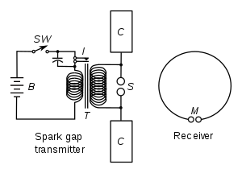
Figure 4.1 – Diagram illustrating apparatus for generating and detecting radio waves. A spark transmitter with a spark gap is powered by high voltage pulses from a Ruhmkorff coil (denoted as T in the diagram). The receiver consists of a spark gap and a loop antenna.

In autumn of 1886 Hertz noticed that discharging a Leyden jar (an early day capacitor). He used a Ruhmkorff coil (a type of transformer used to produce high voltage pulses from low DC supplies) driven spark gap (radio transmitter that produces radio waves by means of a spark) as a radiator. His receiver was consisted of a loop antenna and a micrometer spark gap (a device used to measure potential in an electrical circuit [X]

- Dipole Antenna
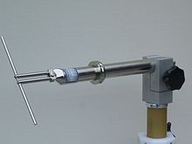
Figure 4.2 – UHF half-wave dipole.
The dipole is the simplest type of antenna, invented by Hertz. It simply consists of two conductors of equal length in the end-to-end orientation with feedlines connecting the two. [Y]

- Radio Transmitter
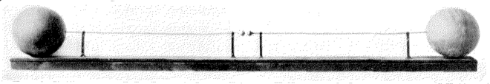
Figure 4.3 – Hertz’ first radio transmitter
Created only by one-meter copper wires with a 7.5mm spark gap between them and a pair of 30cm zinc spheres at the end.
When Hertz powered this transmitter (with an induction coil) it produced waves at a frequency of around 50MHz, proving Maxwell’s theory that electric and magnetic fields could travel through space (electromagnetic waves).

- Radar
While gathering data to show the existence of electromagnetic waves, Hertz discovered that radio waves are reflected by metallic objects. This was the foundation for the technician Christian Hulsmeyer to carry out the first detection experiment using radar waves in 1904.

V. Impact and Applications

Hertz, despite proving Maxwell’s theory felt like this was in no way significant. He has stated: “I do not think that the radio waves I have discovered will have any practical application”. When asked about the applications of his discoveries, he replied “Nothing, I guess”. This could not be further from the truth as many of his inventions have changed the world.
Hertz’ proof of electromagnetic waves led to a giant amount of experimentation with this newfound form of electromagnetic radiation. Within ten years of his discovery other researchers employed these radio waves into the first wireless telegraphy radio communication systems. Hertz’ findings are the reason we have radio broadcasting and television.

A. Rabbit ears
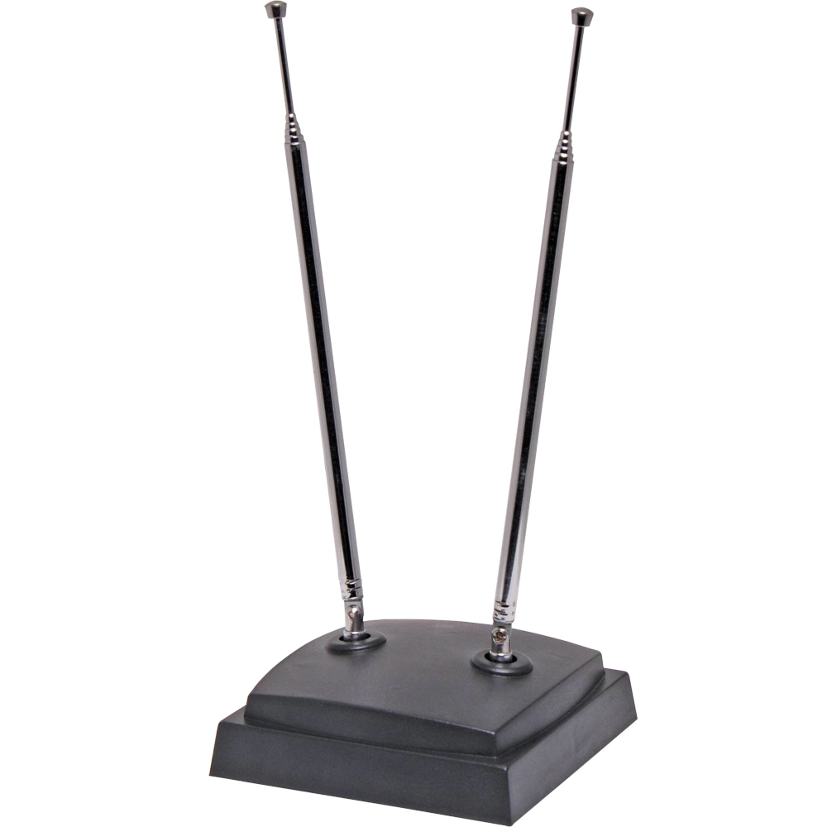
Figure 5.1 – Rabbit ears.
One of the most common applications of the dipole antenna (see IV.b) is the rabbit ears. It is constructed of two telescoping rods that can be extended out to 1m length, used to receive the VHF terrestrial television bands.

B. Radar
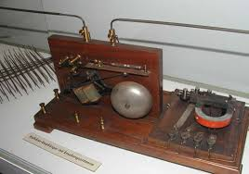
Figure 5.2 – Telemobiloscope
As previously mentioned in 4.D Christian Mulsmeyer created a device called the telemobiloscope. This is a device used to measure the transit time of reflected waves and was the first practical “radar” machine. The most common uses of radar today are navigation and monitoring sea vessels or air traffic. Further scientific applications include the measurement of near-Earth orbit to gain insight into space travel, meteorology (weather radar) and even detection of potentially unstable structure after a landslide.

X. CONCLUSIONS

The conclusions of your paper. Future work directly from the paper is also acceptable.
This Word template for A4 pages has already defined styles for use in the paper.

REFERENCES

[1] IEC History. Iec.ch.
[X] The creation of scientific effects : Heinrich Hertz and electric waves. Chicago: University of Chicago Press. 1994. ISBN 9780226078915. OCLC 704274080. Retrieved September 25, 2015.
[Y] Stutzman, Warren; Thiele, Gary (1981). Antenna Theory and Design. John Wiley & Sons, Inc. pp. 212–220. ISBN 0-471-04458-X.
[2.1] (Nationalmaglab.org. 2020. Heinrich Hertz - Maglab. Available at: <https://nationalmaglab.org/education/magnet-academy/history-of-electricity-magnetism/pioneers/heinrich-hertz> [Accessed 15 October 2020].

